System Requirement Specifications
(Version: 1.0)
Team: 5

TABLE OF CONTENTS
- Introduction
  - Purpose................................................................................................3
  - Scope...................................................................................................3
  - Document Conventions.......................................................................3
  - Intended Audience..............................................................................3
  - References...........................................................................................4
- Overall Description
  - Product Perspective.............................................................................4
  - Product functions................................................................................5
  - User characteristics..............................................................................5
  - Design and Implementation Constraints.............................................6
  - Assumptions and Dependencies..........................................................6
- Specific Requirements
  - Functional Requirements.....................................................................7
  - Performance Requirements.................................................................8
  - Logical Database Requirements...........................................................8
  - Design constraints...............................................................................8
  - Software system Attributes.................................................................8
- Sign off sheet.................................................................................................9

1.0Introduction
  - Purpose
The SRS document specifies all the functional, non-functional requirements, and performance requirements. It, besides establishing the basis of agreement between the client and the developing organization as to what the software product would do, also establishes a reference for the validation of the final product.

The document under consideration is a part of our software project in IT-314 Software Engineering course, included in the curriculum of B-Tech ICT which is being taught for the academic session winter 2011 in DA-IICT.

  - Scope
The primary objective of the project is to notify the student by sending an SMS to his/her mobile whenever he/she has a new mail in his webmail inbox with the name of the sender and the subject of the mail as the content of the SMS text (i.e., the 'From address' and 'Subject' of the mail as the content). The system would be particularly useful to students who check their webmail less often or by some reasons, are unable to check it frequently. The students would promptly be notified about new mails via an SMS to the mobile number that have been provided by them in their respective accounts. This would possibly help reducing the chances of a student missing the deadlines.

The application can be used by an institute that uses zimbra web-client server. Its scope can be extended to a task reminder system.

  - Document Conventions
- Body[12, Calibri, Black, Regular]
- Subheading[14, Calibri, Black, Regular]
- Footnotes[10, Calibri, Black, Regular]

  - Intended Audience
It is suggested that the SRS be read in the same order in which it is compiled. The readers for the document are:
- Documentation Writers
- Designers
- Developers
- Testers
- Users (Potential Users and End Users)
- Maintenance person

  - References

[1] Roger S. Pressman, “Software Engineering-a practitioner’s approach”, 5th ed., McGraw-Hill.
[2] Prof. Asim Banerjee’s lecture slides on “Software Engineering”.
[3 IEEE Guide to Software Requirements Specifications (Std 830-1993)

- Overall Description
2.1Product perspective
This is a project is meant to add an additional functionality to the existing zimbra client-server application that the institute is using. It is a follow-on member in some sense to the existing 71 zimlets that have been developed by various institutes including zimbra itself.
The text sent in the SMS would primarily contain information about the subject and sender name. This project has been inspired from the SMS functionality provided by various email vendors. The motivation, however is to help the students not to miss any deadlines and important information, because if somehow he/she missed to check his/her mail account. True till the present day, neither does zimbra provide any such in-built facility, nor has any other person-individual or part of any organization developed any dedicated zimlet or an application to serve the purpose.
The project is universal in its approach in that the benefits of the application are open to the faculty and the administrative department in addition to the student community at the Institute.
Focus of the project is on helping the user not to miss on any deadlines or any important information, because of not checking his/her account on time or for some other reason. Zimbra being available as an open-source code, any development made within the zimbra environment would have its code freely available to everyone, both for one’s use as well as for development purposes. Any institute, that uses zimbra as its mail client-server can use the project to enhance the working ability of their client –server mail system.
  - Product Functions
The product has a very dedicated function of sending the user an SMS text every time he/she receives an email in the webmail inbox. However, the features of the product can be listed as below:
- Sending SMS to user for a mail received in the inbox.
- Disabling and enabling of the messaging service.
- Filtering the sms’s on the basis of users or subjects or both.
Product service can be used by any organization that uses zimbra.
  - User Characteristics
    - Client
Dhirubhai Ambani Institute of Information and Communication Technology (DA-IICT), Gandhinagar.
    - Stakeholders
- Student Community
- Administrative department
- Faculty
Each of the specified stakeholders has accessibility to the following features:
- Setting the mobile number
- Changing mobile number
- Changing password
- Unregistering
- Enabling or disabling message delivery system
- Filtering users
- Filtering subject

  - Design and Implementation Constraints
    - Hardware constraints:
Server requires a minimum 1.2 GHz P4 Processor, 10 GB Hard Disk, 512 Mb Random Access Memory, Internet connectivity and other basic peripherals like keyboard, mouse etc.
As time passes, the hard-disk space requirement on server may increase as the number of users may increase. Thus, we need to keep increasing the hard-disk space with time to store the increasing data-base. Processor and RAM needs to be upgraded with time to provide low response time to users. The increase in Internet bandwidth might be required in case, for handling tremendous traffic.
2.4.2 Software Constraints:
The server can be deployed on Linux(ubuntu 10.10 or later) or Microsoft Windows XP or later operating System or later versions of the above.
The server must be supporting the following softwares:

- Apache Geronimo Suite
- JDK 1.6 or later

JavaScript enabled web browser like Internet Explorer 6 +, Mozilla Firefox 1.0+, Safari2+, Opera 9+ etc. must be available at the client side to access the site smoothly. Drivers are needed at the client side to support 1024 X 768 resolution for best viewing.

2.4.3 User Documentation
The various materials available under user documentation include:
- User manual
- Help
- Frequently asked questions
Help would be available as a downloadable user manual document. Hard copy of the User manual would be provided along with the software.
2.5 Assumption and Dependencies
- Maximum Users is limited to a certain number: This may be a major assumption for two reasons that load on polling may increase, if the number of users drastically increases. Moreover a dedicated server is required.
- Space for growing database is available: This is not a major assumption because the amount of space required for each user is in few MegaBytes
- Zimbra would always continue its support for REST APIs: In the event that Zimbra withdraws its support for REST APIs, imap or pop3 would have to be used.
- The software (open source) being used has no associated bugs: Alternative or substitute software would have to be used.
- Required SMS gateway is both configurable and available at affordable price.
- The server supports the following:
- Apache Geronimo Suite
- JDK 1.6 or later

- Specific Requirements
  - Functional Requirements
    - Use Case:
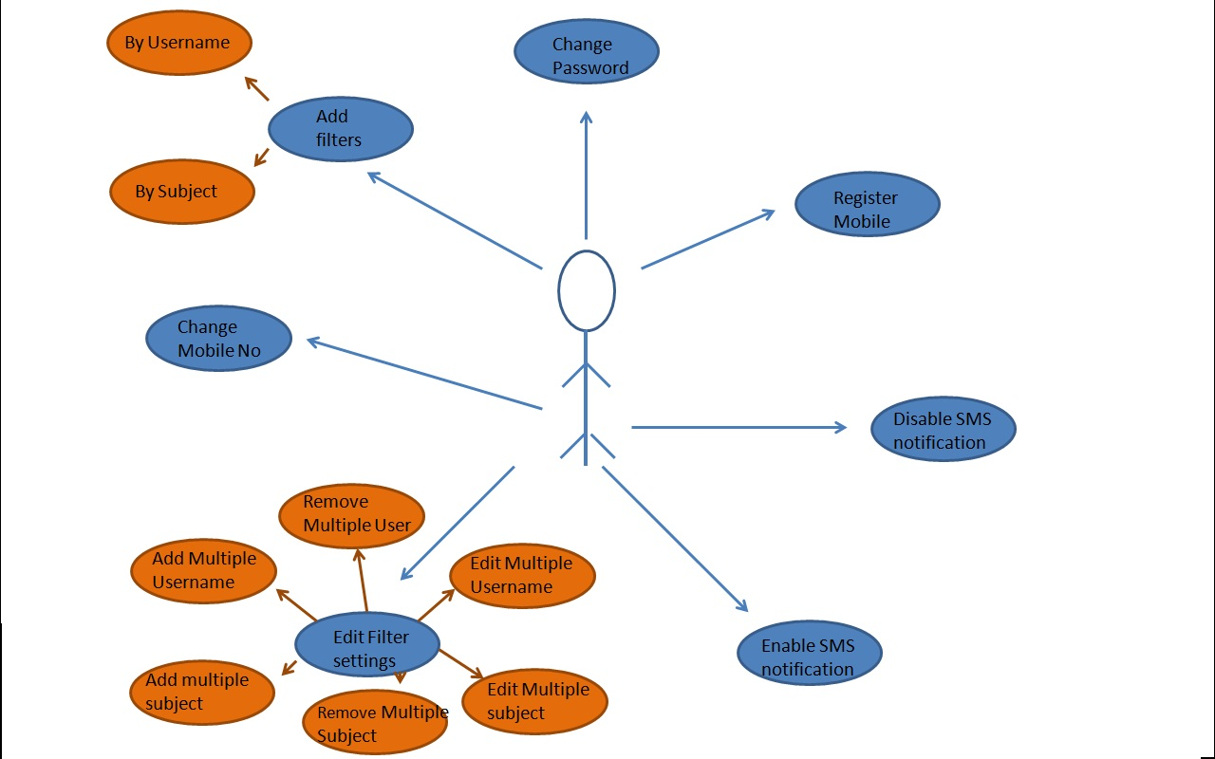

  - Performance Requirements

- There is no limit on the number of users (as far as the number of students in the institute doesn’t increase drastically).
- Our integrated system is having some constraints because of internet factors like LAN speed, server speed, the type of browser that the client is using, in addition to the gateway support for it(i.e., the SMS package subscribed by the client)
- There is a limit on the number of SMS that can be sent. The user would be responsible for ensuring that the quota is not exhausted by the SMS disable functionality. They could pay more if they wish to refill their SMS quota.

  - Logical Database Requirements
- Database version: Apache Derby 10.2 or later
- Memory Requirements
  - Design constraints
- Security: SSL security issue in webmail exists, so the same security arises even for message notification application (via webmail).
- Session implementation not possible because of lack of expertise and time constraint.
- Task and Reminder implementation: This can be an incremental version of the project. The aim of the project under consideration is to send a SMS notification for webmail and thus, this feature has not been included in the current version of the project.
- Zimlet implementation via xml not possible: Since vmware took over zimbra, documentation for modified in-built functions is not available. This leads to integration problems along with a less interactive user environment. Thus, zimlets via jsp implementation is preferred.

  - Software system Attributes
- There is no operating system constraint on our system.
- There is no browser constraint as such for our system. The system will be easily accessible from all standard browsers like Mozilla, Firefox, Internet Explorer, Netscape, Chrome, Opera etc. as long as the client uses zimbra mail-client server.
- Maintenance Issue: A very well documented user manual shall be provided along with the system and even the codes generated shall contain a good amount of comments, so that any person who reads all these documents is easily able to carry out maintenance functions for the system.
- Portability Issue: The system is designed on standard development platforms and thus it is easy to port the server to other locations. The server must however support Apache Geronimo Suite or JDK 1.6 or later.

4.0 SIGN OFF SHEET:
We confirm the accuracy of the information mentioned above:
Name ID:
Salil Shukla 200801001
Anubhav Sharma 200801003
Rajat Talwar 200801005
Hetaswi Vankani 200801016
P.N.V.S. Ravali 200801022
Dhiren Velari 200801031
Sonu Ladia 200801032
Malav Bhavsar 200801054
Vivek Fitkariwala 200801055
Sushant Kumar 200801058

? SRS stands for System Requirements Specification
? In the project under consideration, the client and the potential users are same
? Tailored to our need
? SMS stands for Short Message Service
? ‘Inbox’ is a folder for mail received from outside source.

